Python Packages for Decision Trees

* Sklearn
* Pandas
* NumPy

Example code for a decision tree - <https://www.geeksforgeeks.org/decision-tree-implementation-python/> (halfway down page)

Decision tree is a “non-parametric supervised learning method” which means it learns from sample data to predict an outcome. We could alter this code to take the current state of all of the variables as the sample data and determine a new set of data depending on the traversal of nodes through the tree. So the leaves would be the input that the player has which changes the path travelled along the tree and the outcome would change depending on the player’s input.

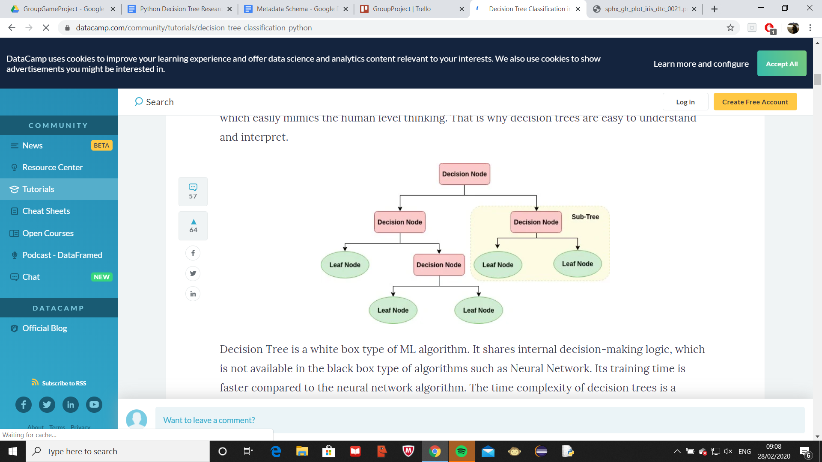

<https://www.datacamp.com/community/tutorials/decision-tree-classification-python>

Variables that can be increased/decreased by tree (cannot directly be controlled by player)

* Cost £
* Cost per month
* Quality of product
* Electricity consumption
* Brick production time
* Truck loading time
* Number of sales
* Material cost
* Amount of waste
* Reputation
* Materials delivered per day
* Quantity of product delivered per day
* Product per box

Variables that the user can change (can be changed directly by player)

* Number of Lines
* Speed of conveyor belt
* Speed of delivery truck
* Temperature
* Pressure
* Number of silos
* Size of boxes
* Size of storage
* Marketing Budget
* Number of Packers
* Material sourcing team budget
* Number of delivery trucks
* Human to Robot worker upgrade
* Waste machine upgrade

**Pseudocode**

def setupGUI(vars1,vars2){

//GUI stuff

If (change made by player){

newData = updateStats(vars1,vars2,changedVarIndex,changedValue); //tuple storing two arrays

}

return newData;

}

def updateStats(vars1, vars2,changedVarIndex,changedValue){

If (object contains variable){

vars1[changedVarIndex] = vars[changedVarIndex]+changedValue;

}

//each node as object holding data, traverses each object

}

def update(){

//runs constantly, updates vars2

}

def main(){

vars1[];

vars2[];

newData = setupGUI(vars1, vars2); //thread 1

update();

vars1 = newData[0];

vars2 = newData[1];

}

main()

**Array 1**

Int numOfLines = 1

Int speedOfConveyer = 1

Int speedOfTruck = 1

Int temp = 230

Int pressure = 10

Int numOfSilos = 1

Int sizeOfBox = 1

Int sizeOfStorage = 1

Int marketingBudget = 100

Int numOfPackers = 1

Int materialTeamBudget = 100

Int numOfTrucks = 1

bool robotUpgrade = False

bool wasteMachineUpgrade = False

**Array 2**

Int totalCash

Int cashPerDay

Int quality

Int electricityConsumption

Int brickTime

Int truckLoadTime

Int numOfSales

Int materialCost

Int amountOfWaste

Int reputation

Int materialsDeliveredPerDay

Int quantityOfProductDelivered

Int productPerBox